

**Sales Manager**

**DETAIL DESIGN DOCUMENT**

**Screen design**

**Project Code:**

**Document Code: Sales Manager-DD – v1.0**

**<Location, issued date of the Document>**

**RECORD OF CHANGE**

#### *A - Added M - Modified D – Deleted

|  |  |  |  |  |
| --- | --- | --- | --- | --- |
| Effective Date | Changed Items | A* M, D | Change Description | New Version |
|  |  |  |  |  |
|  |  |  |  |  |
|  |  |  |  |  |
|  |  |  |  |  |
|  |  |  |  |  |
|  |  |  |  |  |
|  |  |  |  |  |
|  |  |  |  |  |
|  |  |  |  |  |
|  |  |  |  |  |
|  |  |  |  |  |
|  |  |  |  |  |
|  |  |  |  |  |

**SIGNATURE PAGE**

**ORIGINATOR:**<Name> Lê Nguyễn Việt Thanh <Date> 05/12/2018

#### <Position>member

**REVIEWERS:** <Name> <Date>

#### <Position>

<Name, if it’s needed> <Date>

<Position>

**APPROVAL:** <Name> <Date>

#### <Position>

Contents

1 INTRODUCTION 5

1.1 Purpose 5

1.2 Overview 5

1 SCREEN FLOW 6

1.1 Screen Login 7

1.2 Screen register 9

1.3 Home screen 11

1.4 Detail screen 13

1.5 User Infor screen 15

1.6 Logout Screen 17

### INTRODUCTION

## Purpose

This part will give general description of the document including:

* + - *Purpose of document.*
    - *What are contained in the doc*
    - *Reader of document*
    - *Other description about scope of document, limitation,.*

## Overview

This application allows users to search for places to book tour

### SCREEN FLOW

<List of screen>

|  |  |  |
| --- | --- | --- |
| **No** | **Screen Name** | **Description** |
| 1 | Login screen | When the user finishes all the steps, click the button to continue login the account without an account |
| 2 | Quản lý screen | If successful login allows the user to choose 3 steps to proceed to the management page |
| 3 | Quản lý sinh viên screen | Enter all fields and click on the 3 buttons below, if successful will appear specific list that user wants. |
| 4 | Quản lý lớp screen | Enter all fields and click on the 3 buttons below, if successful will appear specific list that user wants. |

## Screen Login

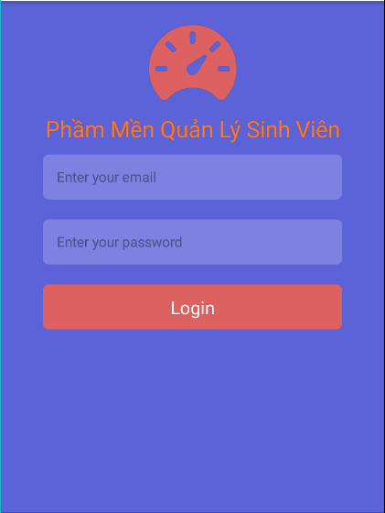

**Image 1: screen Login**

|  |  |  |  |  |  |
| --- | --- | --- | --- | --- | --- |
| **No** | **Component Name** | **Required** | **Format** | **Reference** | **Note** |
|  | 1 field for input email/password |  |  | * Use Text : * Text : Email/ Username * Use TextInput : * fontSize: 20 * Color :#FFFFFF * Backgroudcolor:# 1c313a |  |
|  | 1 field for input password |  |  | * Use Text : * Text : Password * Use TextInput : * fontSize: 20   Color :#FFFFFF |  |
|  | 1 button for login |  |  | * Use Buttom : * Text : Login * fontSize :15 * Color :#FFFFFF * Background :#FF0000   textAlign="center". |  |

## Screen Quản lý

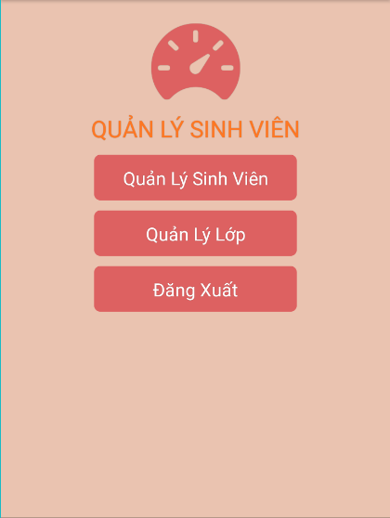

**Image 2: Screen quản lý**

|  |  |  |  |  |  |
| --- | --- | --- | --- | --- | --- |
| **No** | **Component Name** | **Required** | **Format** | **Reference** | **Note** |
|  | 1 button |  |  | * Use Buttom : * Text : Xóa * fontSize :15 * Color :#FFFFFF * Background :#FF0000 * textAlign="center". |  |
|  | 1 button |  |  | * Use Buttom : * Text : Sửa * fontSize :15 * Color :#FFFFFF * Background :#FF0000 * textAlign="center". |  |
|  | 1 button |  |  | * Use Buttom : * Text : Thêm * fontSize :15 * Color :#FFFFFF * Background :#FF0000 * textAlign="center". |  |

## Quản lý sinh viên screen

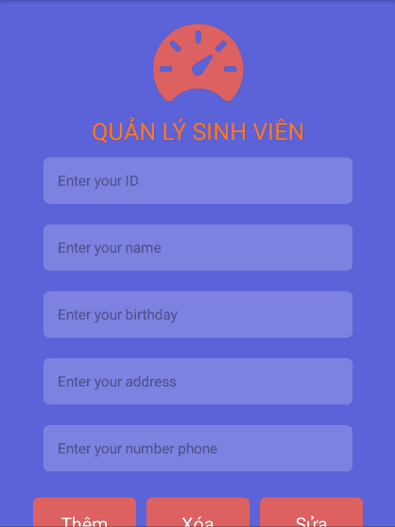

**Image 3: Quản lý sinh viên screen**

|  |  |  |  |  |  |
| --- | --- | --- | --- | --- | --- |
| **No** | **Component Name** | **Required** | **Format** | **Reference** | **Note** |
|  | 1 button |  |  | * Use Buttom : * Text : Xóa * fontSize :15 * Color :#FFFFFF * Background :#FF0000 * textAlign="center". |  |
|  | 1 button |  |  | * Use Buttom : * Text : Thêm * fontSize :15 * Color :#FFFFFF * Background :#FF0000 * textAlign="center". |  |
|  | 1 field for input ID |  |  | * Use Text : * Text : ID * Use TextInput : * fontSize: 20 * Color :#FFFFFF * Backgroudcolor:# 1c313a |  |
|  | 1 field for input Name |  |  | * Use Text : * Text : Name1 * Use TextInput : * fontSize: 20   Color :#FFFFFF |  |
|  | 1 field for input Birthday |  |  | * Use Text : * Text : Birthday * Use TextInput : * fontSize: 20 * Color :#FFFFFF * Backgroudcolor:# 1c313a |  |
|  | 1 field for input address |  |  | * Use Text : * Text : address * Use TextInput : * fontSize: 20   Color :#FFFFFF |  |
|  | 1 field for input number phone |  |  | * Use Text : * Text : number phone * Use TextInput : * fontSize: 20   Color :#FFFFFF |  |
|  | 1 button |  |  | * Use Buttom : * Text : Sửa * fontSize :15 * Color :#FFFFFF * Background :#FF0000 * textAlign="center". |  |

## Quản Lý lớp screen

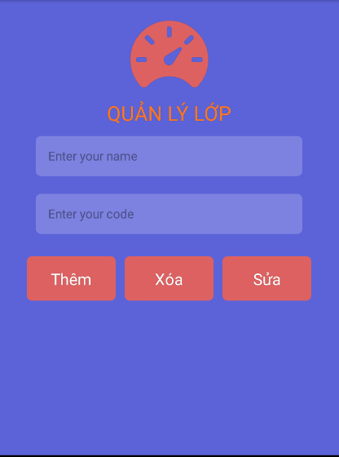 **Image 4: Quản lý lớp page**

|  |  |  |  |  |  |
| --- | --- | --- | --- | --- | --- |
| **No** | **Component Name** | **Required** | **Format** | **Reference** | **Note** |
|  | 1 field for input name |  |  | * Use Text : * Text : name * Use TextInput : * fontSize: 20   Color :#FFFFFF |  |
|  | 1 field for input code |  |  | * Use Text : * Text : code phone * Use TextInput : * fontSize: 20   Color :#FFFFFF |  |
|  | 1 button |  |  | * Use Buttom : * Text : Thêm * fontSize :15 * Color :#FFFFFF * Background :#FF0000 * textAlign="center". |  |
|  | 1 button |  |  | * Use Buttom : * Text : Xóa * fontSize :15 * Color :#FFFFFF * Background :#FF0000 * textAlign="center". |  |
|  | 1 button |  |  | * Use Buttom : * Text : Sửa * fontSize :15 * Color :#FFFFFF * Background :#FF0000 * textAlign="center". |  |

--------------------------- End Document -----------------------